Chris Devereux MEdTech, BSc (Hons), PGCE, DASE, CASE, Member IATEFL/BALEAP
British Council Registered Education and English Language Consultant

`Excellence and the Individual in Partnership`
__________________________________________________________________

Chris Devereux: `The Magical Musical Mystery Tour`
On the Guitar-Bouzouki
- Bob Dylan: `Knockin` on Heaven`s Door.`
- Lennon/Mc`Cartney: `I Saw Her Standing There.`
- Lennon/Mc`Cartney: `Hey, You`ve Got to Hide Your Love Away.`
- David Gates/Bread: `Everything I Own.`
- Simon & Garfunkel: `The Only Living Boy in New York`
- John Martyn: `Excuse Me Mister.`

On the Octave Mandolin/Mando-Cello
- Instrumental: Hughie Jones: `The Ellen Vannen Tragedy`

On the Flat-Backed Mandolin
- Lindisfarne: `Together Forever`
- Paul Mc`Cartney: `Dance Tonight`

On the Renaissance Lute
- Instrumentals/Songs: John Dowland: `The Frog Galliard/Pavan Lachrimae`, Taize Community: Plainsong Chant
- Paul Simon: `April Come She Will.`

The Magical Musical Mystery Tour is a `play-on-words` of the Beatles` famous concept album. In reality, it is a live, interactive selection of my favourite songs which include Sacred Music, Early Music, Plainsong, the great Traditional Music of these islands and good old Rock`n`Roll. The above play-list is often changed to suit the particular audience and lasts normally for forty-five to fifty minutes, though I often have requests for more songs.
I like the `talk` to be interactive and educational in the spirit of the U3A and so each song is preceded by historical background information which gives the audience the opportunity to question or to comment.
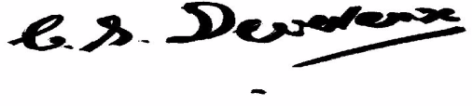
Enjoy!
Chris Devereux

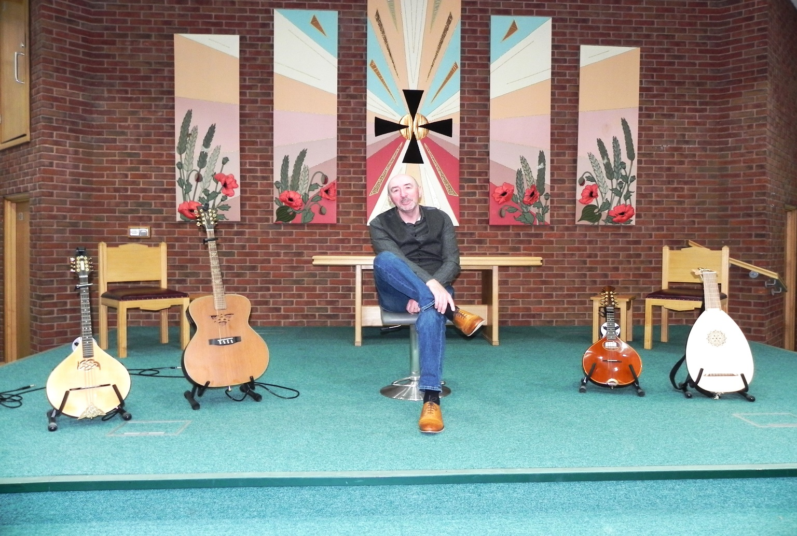

Magical, Musical, Mystery Tour 3 at Christ Church, Southport, May, 2024

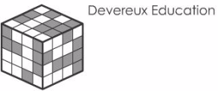



No.1 Lancaster House, 4 Lancaster Road, Birkdale. PR8 2FZ Tel./Fax 0044 1704 566933 (mobile 0044 7985 293791)
Email info@devereuxeducation.co.uk
Website www.devereuxeducation.co.uk

